Graphic Organizer

Connections

How are people and places connected to each other?

How are people connected to the Earth?

Movement

Human/ Environment
Interaction

Big Ideas Card

Big Ideas of Lesson 1, Unit 3
- In studying human geography, geographers examine how people and places are connected to each other, as well as how people are connected to the Earth.
- Human geography has two main themes: movement and human/environment interaction.
- In studying movement, geographers ask questions such as: Why do people move?, How does the movement of people connect places?, and How do geographic features impact movement?
- In studying human/environment interaction, geographers ask questions such as: How do people use the Earth?, How do people change the Earth?, and What are the consequences of changing the Earth?

Word Cards

1  the five themes of geography  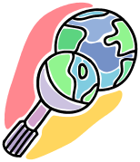  five big ideas that help people understand geography  Example: Location is one of the five themes of geography.  (SS040301) | 2  movement    the geographic theme that explains how and why people, goods, and ideas move  Example: The theme of movement helps us understand how places are connected to other places.  (SS040301)
3
human/environment interaction

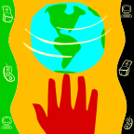
ways in which people use, adapt, or modify with the Earth

Example: When people build new roads they are interacting with the Earth.

(SS040301)

Questions Geographers Ask

Theme | Questions
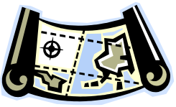  Location | Where is it?  - What is its absolute location?  - What is its relative location?
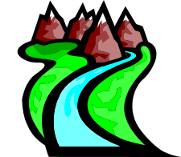  Place | What is it like there?  - What are its natural characteristics?  - What are its human characteristics?
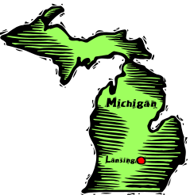  Regions | How might common geographic characteristics help understand this place?  - How can the place be divided into regions?  - To what regions does the place belong?
Movement | How is the place connected to other places?  - How and why have people, goods, and ideas moved in and out of the place?
Human/Environment  Interaction  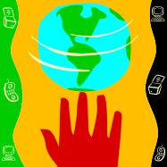 | How do people interact with the environment?  - How have people used the environment?  - How have people adapted to the environment?  - How have people modified or changed the environment?

Group Brainstorming Sheet

Ways People and Places are Connected to Each Other | Ways People are Connected to the Earth

Group Brainstorming Sheet – Sample Answers

Ways People and Places are Connected to Each Other | Ways People are Connected to the Earth
Places are connected through transportation networks that include roads, air connections, and shipping.  Places are connected by people moving from one place to another.  Places are connected through the Internet and computers.  Places are connected by trade networks and the exchange of goods and services.  Places are connected through international organizations like the United Nations.  Places are connected when people share a cultural trait like religion.  Places are connected by people traveling. | People are connected to the Earth because they use the resources of the Earth like water, trees, and soil.  People are connected to the Earth because they have built things like cities, dams, bridges, and roads all over the Earth.  People are connected to the Earth because the Earth provides many different environments for people to live in.  People are connected to the Earth through the ways in which they have changed the Earth.
Map #1
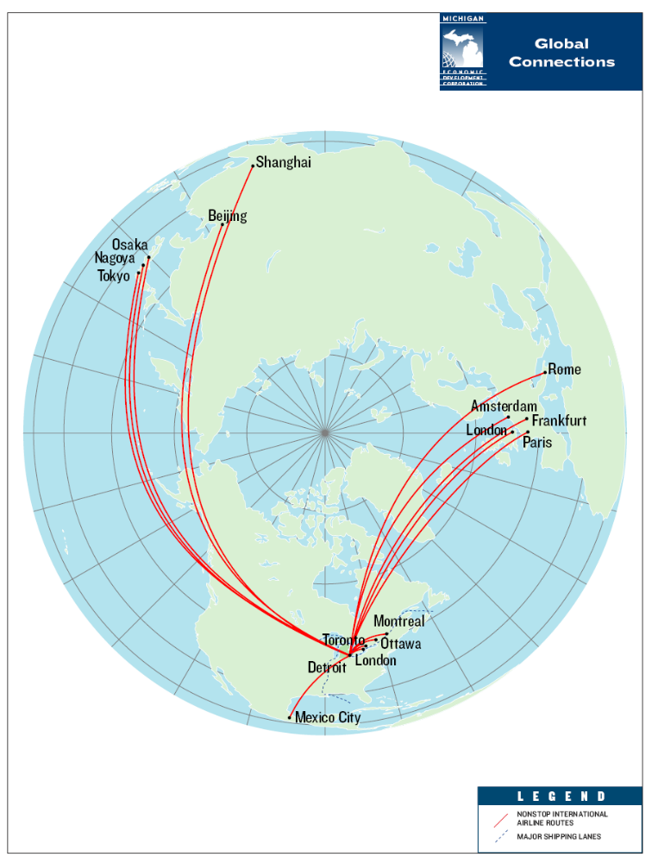

Source: Michigan Global Connections. MEDC Website. 12 November 2008 <http://ref.michigan.org/medc/miinfo/mimaps/>.
Map #2
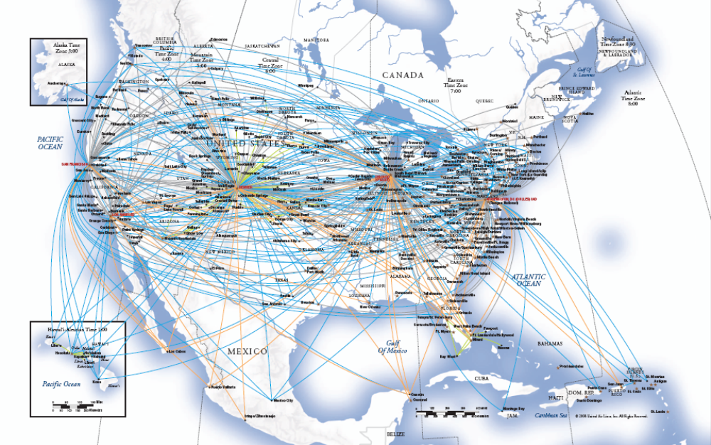

Map #3
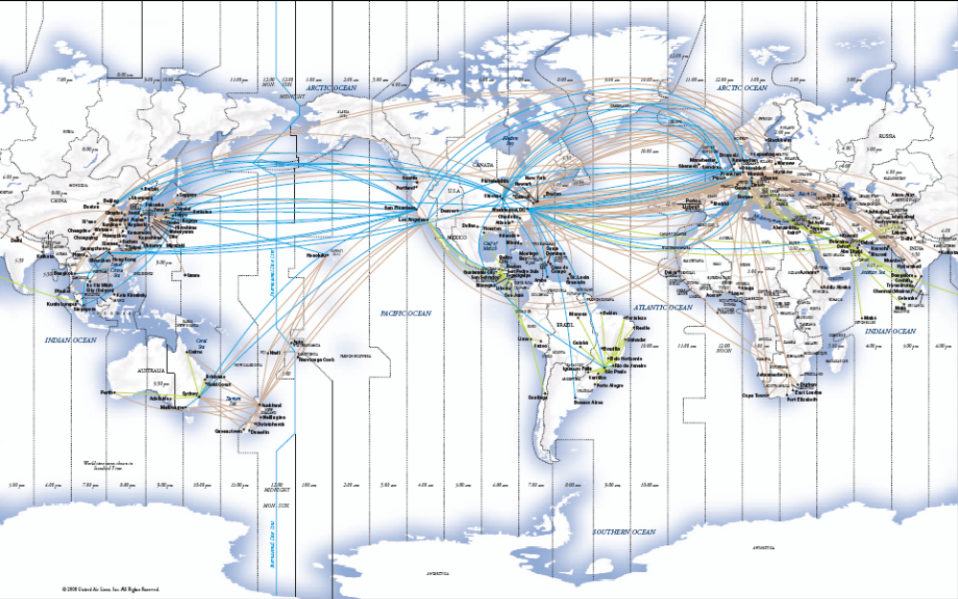

Source: <http://www.united.com/ual/asset/unitedroutes_World_8_08.pdf>.
Analyzing Maps

What do you think the maps show?
How are the maps related to the theme of movement?
What questions do the maps help answer?
What are some questions the maps raise?
Map #4

Percent of People that are Foreign Born

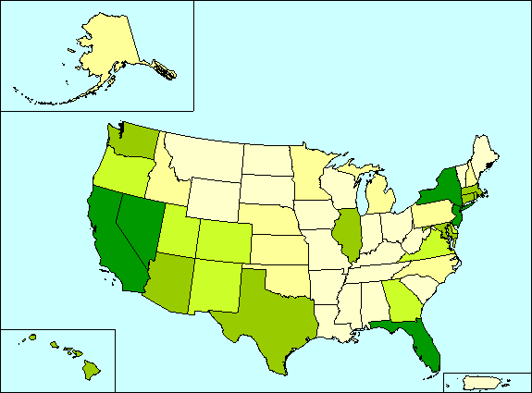



Source: <http://factfinder.census.gov/jsp/saff/SAFFInfo.jsp?_pageId=thematicmaps>.

Book Analysis

Ways People had Changed the Earth | Consequences of the Changes
Book Analysis – Sample Answers

Ways People had Changed the Earth | Consequences of the Changes
There were mountains of trash everywhere.  Many trees had been cut down.  Factories with huge smokestacks had been built.  A hotel had been built on Mount Everest.  People had overfished the Earth’s waters.  Cars and trucks and roads were everywhere.  Smog had filled Grand Canyon. | The trash had nearly buried the houses in neighborhoods so that people couldn’t live there anymore.  There were few trees left.  The air was very polluted and it caused health problems for people.  An important natural landmark had been turned into a tourist attraction.  There were almost no fish left.  There was a huge amount of traffic and little green space left.  There was so much smog people could not even see the Grand Canyon.

