Graphic Organizer

Migration
within the United States

WHEN?

WHO?

WHERE?

WHY?
From
Where?
To
Where?
Push
Factors
Pull
Factors

Big Ideas Card

Big Ideas of Lesson 2, Unit 3
- Both geographers and historians have studied how and why people have moved, or migrated, within the United States.
- Push factors are reasons people leave a place. Some examples of push factors include a lack of freedom, a shortage of jobs, war, famine, or high cost of living.
- Pull factors are reasons why people settle in a particular place. Some examples of pull factors include economic opportunities, freedom, family, or culture.
- Not everybody freely chose to move to new places in the United States. Native Americans were often forced off their land and forced to move to new places.
- People continue to move within the United States.

Word Cards

Word Cards from previous lessons needed for this lesson:

- Movement – Word Card #2 from Lesson 1

4  migration  the movement of people to a new place  Example: Geographers and historians study the migration of people by exploring how and why people move to new places.  (SS040302) |   5  push factors  things that tend to push people out of a place  Example: When people have a hard life in a place, this can be a push factor that encourages them to move to a new place.  (SS040302)
  6  pull factors  things that pull people to a new area  Example: Jobs and the chance for a better life can pull people to a new place.  (SS040302) | 7  slavery    a system that forced people to work and treated enslaved people as property  Example: Many enslaved people wanted to move North in the hope of finding freedom.  (SS040302)
8
Underground Railroad


a secret group of routes, safe places and people that helped enslaved people escape to freedom

Example: Many houses in Michigan were part of the Underground Railroad.

(SS040302)

T-Chart

PUSH  FACTORS | PULL  FACTORS

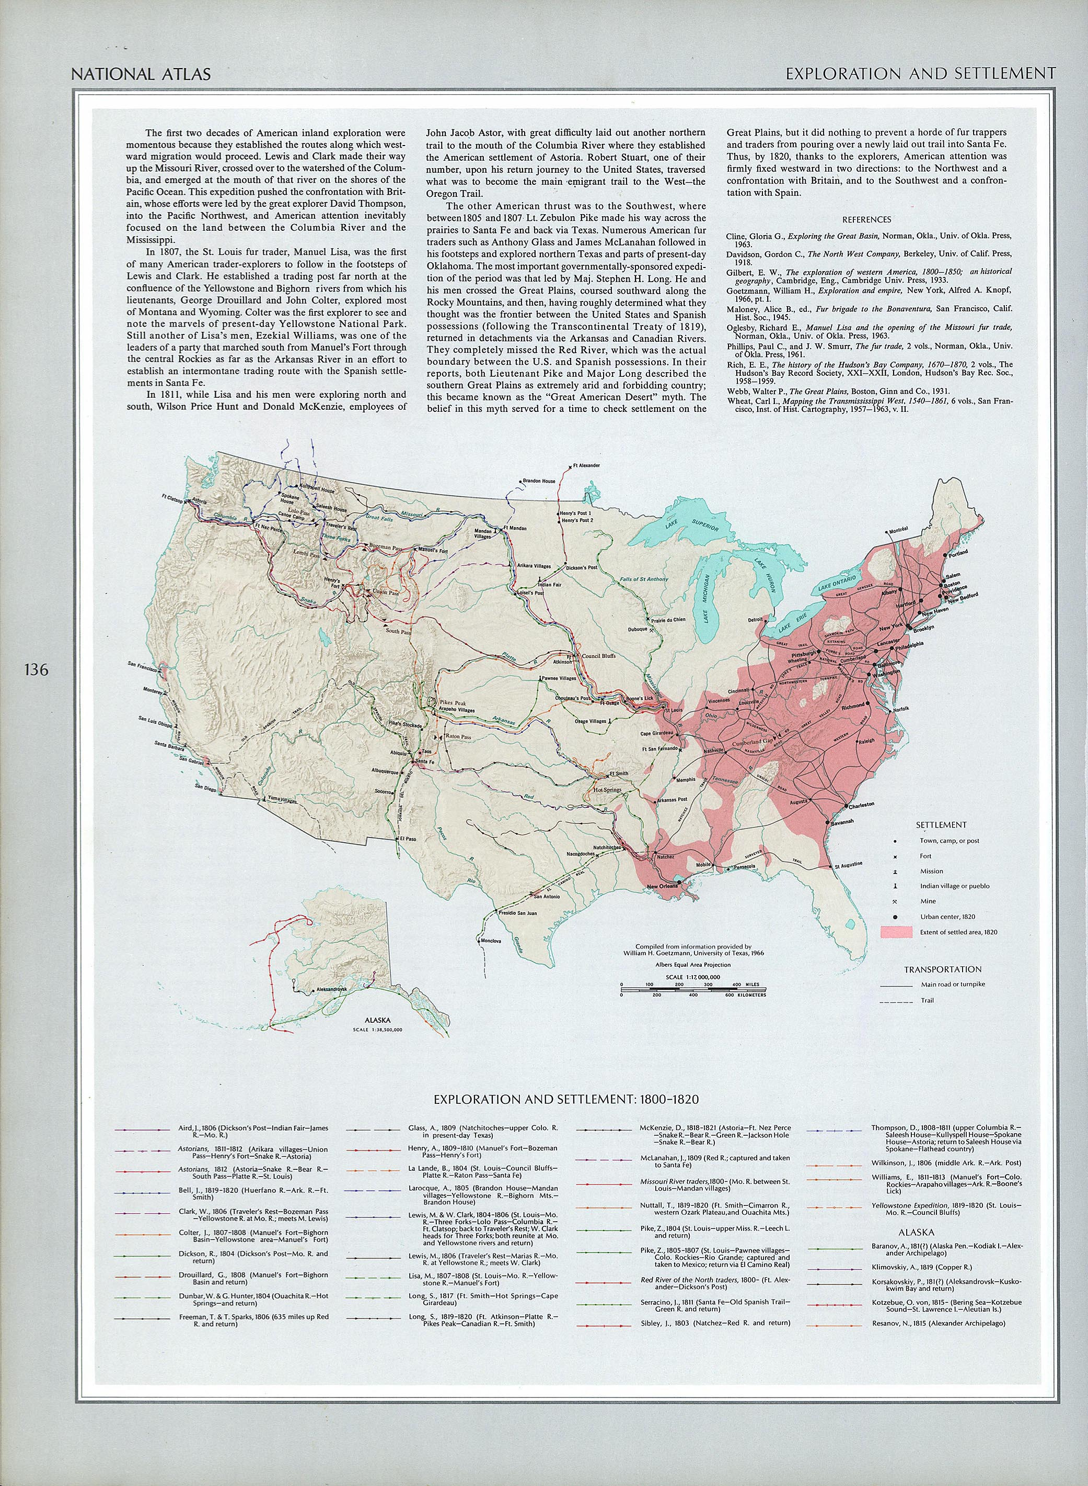
Source: <http://www.lib.utexas.edu/maps/united_states/exploration_1800.jpg>

EXPLORATION AND SETTLEMENT 1800-1820
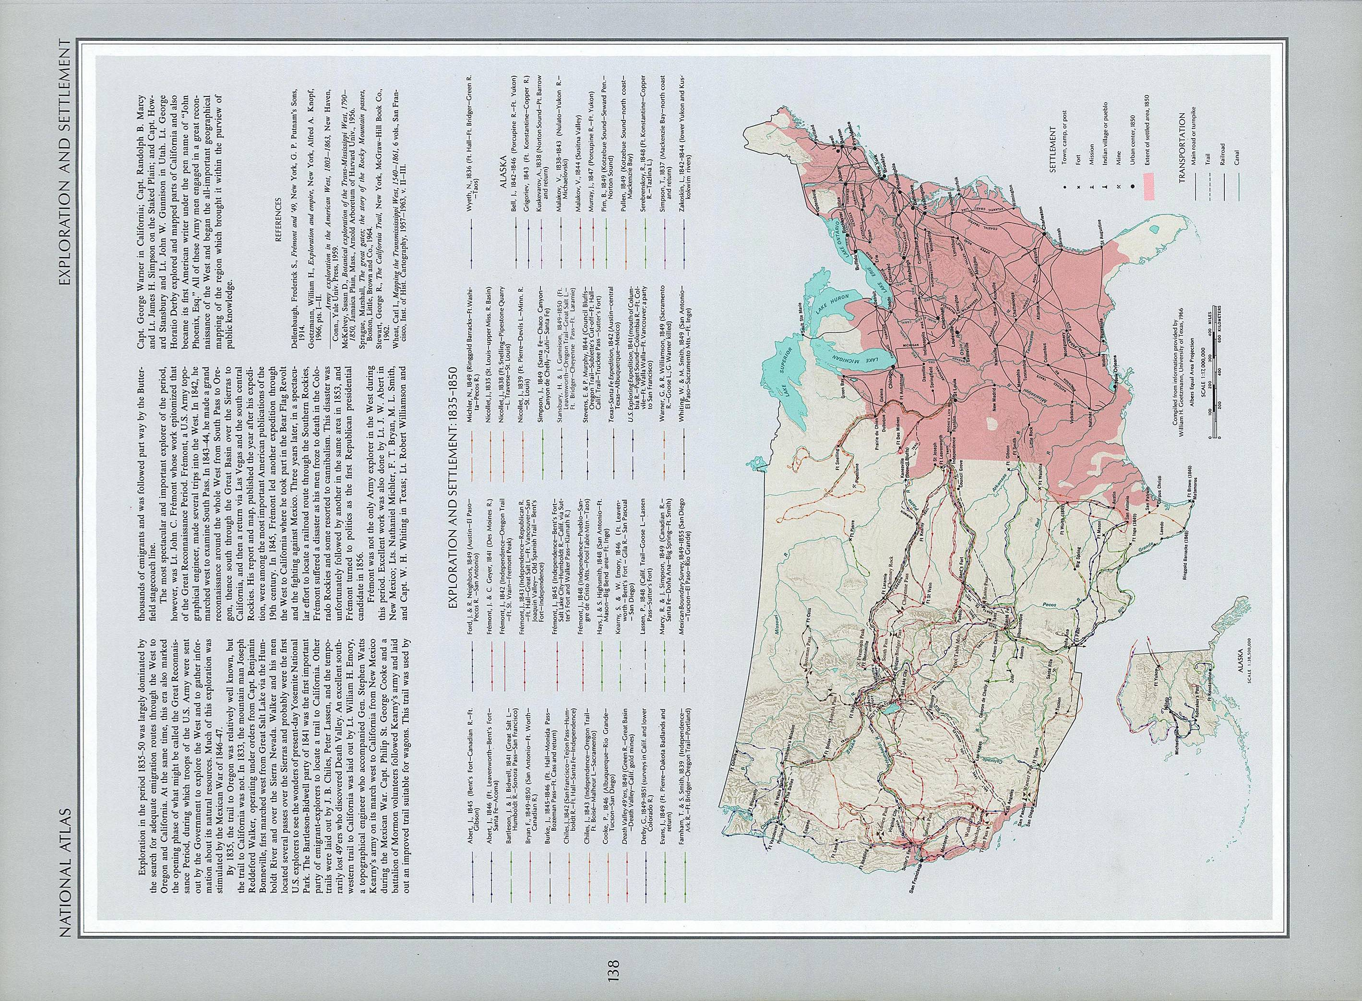
Source: <http://www.lib.utexas.edu/maps/united_states/exploration_1835.jpg>.

EXPLORATION AND SETTLEMENT 1835-1850
Migration Chart

 | Who | Where | When | Why
WESTWARD MOVEMENT |  | From __________  ______________  To ____________  ______________ |  | Push Factor:
 |  |  |  | Pull Factor:
UNDERGROUND RAILROAD |  | From __________  ______________  To ____________  ______________ |  | Push Factor:
 |  |  |  | Pull Factor:
ORPHAN  TRAINS |  | From __________  ______________  To ____________  ______________ |  | Push Factor:
 |  |  |  | Pull Factor
THE “GREAT MIGRATION” |  | From __________  ______________  To ____________  ______________ |  | Push Factor:
 |  |  |  | Pull Factor
NATIVE AMETICAN REMOVAL |  | From __________  ______________  To ____________  ______________ |  | Push: Factor
 |  |  |  | Pull Factor:
Migration Chart – Sample Completed Chart

 | Who | Where | When | Why
WESTWARD MOVEMENT | Settlers and Pioneers | From states in the Eastern part of the U.S.  To states in the west such as Michigan, and later to Oregon and Nebraska | From the early 1800s to around 1900 | Push Factor:  Lack of opportunity  Pull Factor:  Farm land  Adventure
UNDERGROUND RAILROAD | Enslaved people in southern slave states. | From slave states in the South  To states in the North and to Canada | From the 1840s to around 1860 just before the Civil War. | Push Factor:  Slavery  Pull Factor:  Freedom
ORPHAN TRAINS | Homeless orphans in New York City | From New York City to small towns and farms in the Midwest. | Mid–1850s to the late 1920s | Push Factor:  No family or home  Pull Factor:  The chance for a home and family
THE “GREAT MIGRATION” | African Americans in the South | From the South to cities in the North like Detroit and Chicago | 1900 to around 1940 | Push Factor:  Racism and lack of opportunity  Pull Factor:  Jobs and the hope of a better life
NATIVE AMERICAN REMOVAL | Native Americans  such as the Potawatomi | From states like Michigan to states like Kansas and Oklahoma. | 1830 | Push Factor:  They were pushed out and relocated.  Pull Factor:  US government provided specific lands for Native Americans

Michigan People Important in the Underground Railroad

Laura Smith Haviland

- Lived in Adrian and led escaped slaves to Canada.
- Southern slave owners offered a $3,000 reward for her capture.
- She and her family also opened one of the first schools in Michigan for black children.

George De Baptiste

- A black businessman who bought a ship to take escaped slaves across the Detroit River to Canada.
- He was also a member of the Second Baptist Church, which was an important station on the Underground Railroad. This church, which still exists in downtown Detroit, helped as many as 5,000 slaves escape to freedom.

Sojourner Truth

- Was born a slave in New York in 1797 and freed in 1828.
- She became an abolitionist, a person who believed slavery should be made illegal, and a supporter of voting rights for women.
- In 1856 she moved to Battle Creek.
- She was an excellent speaker and traveled throughout the U.S. speaking out against slavery and for the rights of all people.

Nathan Thomas

- He was a doctor in Kalamazoo County.
- Dr. Thomas started helping slaves in 1843.
- Over 1000 slaves passed through his home.

Primary Source

Oskaloosa Independent
Kansas
December 9, 1910
Wanted! Homes for orphan children.

A company of orphan children under the auspices of the Children's Aid Society of New York will arrive at Valley Falls, Thursday afternoon, December 8.
These children are bright, intelligent and well disciplined, both boys and girls of various ages. They are placed on trial, and if not satisfactory will be removed. Parties taking them must be well recommended. A local committee of citizens of Valley Falls has been selected to assist the agents in placing the children. Applications must be made to and endorsed by the local committee.

Source: Want-Ads. 13 November 2008 <http://www.kancoll.org/articles/orphans/or_wants.htm>.
Analyzing a Primary Source

1. What kind of primary source is this?

2. When was it written?

3. Where was it written?

4. Why was it written?

5. What questions does this primary source make you think of?

Analyzing a Primary Source – Possible Answers

1. What kind of primary source is this?

A newspaper article or advertisement

2. When was it written?

In 1910

3. Where was it written?

In Kansas

4. Why was it written?

There was a group of orphans that had come from New York to Kansas that needed homes.

5. What questions does this primary source make you think of?

Answers will vary but could include:

How did the orphans get to Kansas?

Did the orphans want to come to Kansas?

What happened if no one wanted them?

What happened if they ended up with a mean family?

Did this really happen?

“THE REMOVAL OF THE MICHIGAN POTAWATOMI” – A PLAY

Cast of Characters

Narrator
Potawatomi person 1
Potawatomi person 2
Potawatomi person 3
Potawatomi person 4
Potawatomi person 5
Potawatomi person 6
Potawatomi person 7
Potawatomi person 8
Potawatomi person 9
Potawatomi person 10
Saginaw resident 1
Saginaw resident 2
Saginaw resident 3
Soldier 1
Soldier 2

Act 1

Narrator: We are in Potawatomi territory in the place now called “Michigan.” The year is 1768.
Three Potawatomi people are talking about some recent news.

Potawatomi 1: We have been living here on this land for hundreds of years now. First the
French people came to live nearby and called their place “Detroit.”

Potawatomi 2: But after the British defeated the French in 1763, they took over the city. More
people from England came to settle here in the colonies along the Atlantic Ocean. Since then,
European people have been trying to move further west into our homelands.

Potawatomi 3: Have you heard about the Treaty of Fort Stanwix (STAN-wicks)? They just
signed it last week. The treaty says that the Ohio River will now be the boundary line between
the European and Indian places.

Potawatomi 1: That’s good news. This treaty will help everyone understand which land is
whose. We should be able to relax a little knowing that this boundary is set.

Potawatomi 2&3: Yes, we should.

[They all leave the stage.]

Act 2

Narrator: The year is now 1825. Treaties have been made between some of the Potawatomi nations in Michigan territory and the United States of America. Some Euro-American people in Saginaw are talking about the recent treaties.

Saginaw resident 1: Did you hear this? Since the Potawatomi and other tribes ceded (gave up) their land in the Treaty of Saginaw in 1819 and the Treaty of Chicago in 1821, more of the land in southern Michigan territory is now available for non-Indian people to buy.

Saginaw resident 2: How much land did they give up?

Saginaw resident 1: Most of the southern part of the territory. The Potawatomi ceded (gave up) all of southwestern Michigan south of the Grand River, except the area west of the St. Joseph River.

Saginaw resident 3: What will happen to the Indian people who live on the land now?

Saginaw resident 1: They will have to move to the land reserved for them in southeast
Michigan. This land was reserved by the tribes in the treaties.

Saginaw resident 2: I hear they are building a new road from Detroit to Chicago. This will
force more of the Potawatomi people to be removed soon.

Saginaw resident 3: Well, that may be true, but we all need more land for farming. The land
near the new road will be very valuable.

[They all leave the stage.]

Act 3

Narrator: It is now two years later. Some Potawatomi people are talking on a reservation in
southeast Michigan territory.

Potawatomi 4: This is terrible! A new road is being built from Detroit to Chicago. We are
being forced to exchange our reserved lands here on the east side of Michigan for some land over on the west side of Michigan.

Potawatomi 5: That is terrible! I don’t want to move over there. My family and I have lived
here for many years. I am afraid of what will happen to us.

Potawatomi 6: Do we have to go?

Potawatomi 4: Yes. A treaty was signed in September. We don’t have a choice. We will have
to start moving west soon.

Potawatomi 5: Well, I am not going to move west. I am going to take my family and flee to an
island near here in Canada, where we will be safe. It is called Walpole (WALL-pole) Island. Some people I know have already gone there, so they wouldn’t be forced to move west.

Potawatomi 6: That sounds like a good plan. I think I will go with you.

[They all walk off stage together.]

Narrator: Because of the 1827 treaty, many villages in Lower Michigan territory were
broken up. Far away, new Potawatomi villages were formed. Some people ran away to Walpole Island.

Act 4

Narrator: In 1830, Congress passed the “Indian Removal Act”. This meant that all Indian
people were supposed to move west of the Mississippi River. Only one Potawatomi leader was able to negotiate a separate treaty that allowed his band to stay in Michigan. His name was Chief Leopold (LAY-o-pold) Pokagon (Po-KAY-gon). The rest of the Potawatomi people in Michigan would be forced to leave. This next scene takes place in 1835.

Soldier 1: Okay, everyone here has to start packing. We have been told by the government to remove you to a reservation in Kansas, across the Mississippi River.

Potawatomi 7: What is this all about?

Soldier 2: After the treaty of Chicago was signed in 1833, you were told you would have to
move to reservations in the west. Now it is time to go.

Potawatomi 8: What if we don’t want to go? We just moved here from eastern Michigan a few
years ago.

Soldier 1: Sorry, but you have no choice in the matter. You’ll have to move west like it says in
the treaty.

[The Potawatomi people follow the soldiers off stage.]

Narrator: The remaining Potawatomi people in Michigan Territory were removed from their
homelands to Kansas in the next few years, although 1,200 people moved into Northern Michigan. Others were allowed by the Canadian government to move to Manitoulin (Man-a-TOO-lin) Island in Upper Canada.

Act 5

Narrator: When Potawatomi people arrived at the new reservations in the west, they found that the land was not good for growing food. They had to rely on the United States government to provide food. The Potawatomi did not even get to stay long in Kansas. Government leaders in the state of Kansas soon wanted the reservation land for non-Indians. They forced the Potawatomi to move again to reservations in Oklahoma.

Potawatomi 9: [Speaking to audience] By the late 1840s, some people from my tribe began
slowly moving back into Michigan, which became a state in 1837. They purchased land and formed new communities. Some of these communities are the homes of many Potawatomi people today.

Potawatomi 10: [Speaking to audience] In 1913, Potawatomi people returning to Wisconsin
were granted a reservation at a place in the Upper Peninsula of Michigan called Hannahville. Today, there are many Potawatomi people who live, work, and go to school on this reservation.

Potawatomi 9: Other groups came back to their Michigan homelands after living in Canada. Many Potawatomi people stayed in the west on the lands reserved for them in Oklahoma.

Narrator: The history of the Potawatomi Removal is a long and often sad story. It is the story of people who were forced to move away from their homelands. In 1934, the United States government passed the “Indian Reorganization Act”. Many tribes organized governments for themselves that would help them keep the lands they reserved for themselves in treaties. Today, some Potawatomi people live on reservations, but many live in cities and towns all over the United States and Canada. The Potawatomi people are proud of their history and their heritage, and they have not allowed themselves to remain permanently separated. For example, every summer Potawatomi people now living in Michigan, Wisconsin, Kansas, Oklahoma, and Ontario come together to celebrate their ties to each other. The Bands rotate the honor and responsibility of hosting what is called the “Potawatomi Gathering.” People have the opportunity to meet distant relatives from all over the country and to celebrate being together.

Play Courtesy of the Nikomis Center in Okemos, Michigan. 13 November 2008 <http://www.nokomis.org/>.

